**Easy desk booking for the hybrid workplace app.**

General overview of the app:

1. App that designates which desks are available in the office.

2. Employees book a desk from the app. Employees can book a desk for the day or in advance right from their phone or on the web. They have the flexibility to choose where to sit, depending on what they need to get done that day.

Admin part functionalities.

1. Can create location(s) entity, office, eg. Amdaris Moldova.  
   Where location/office, can create floors or spaces, eg. floor 1, floor 2.  
   Where floors, can upload maps in pdf, png.

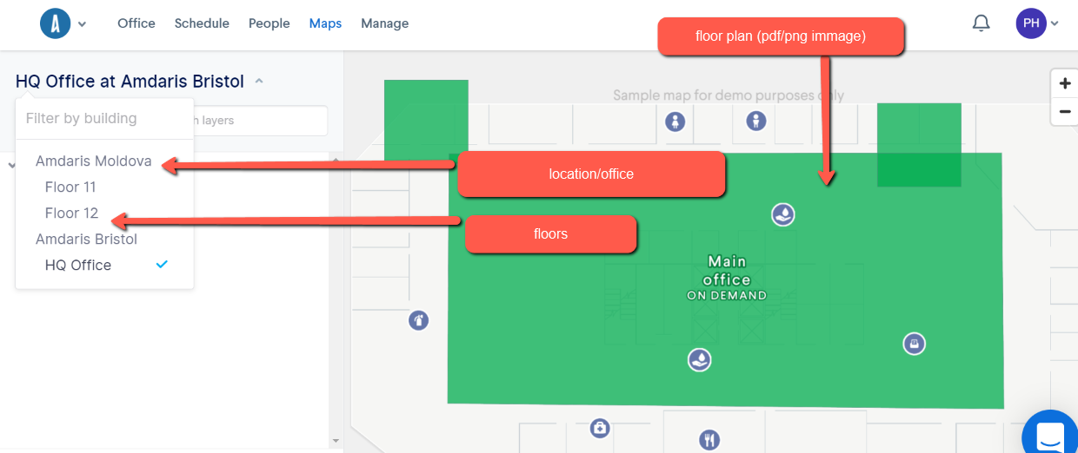

1. Where map, create work desks, etc. work desk 1, work desk 2, etc.

Where work desk creation there are two options:

1. Assigned desk- not available to be booked. Assigned desks are designed for employees working permanently from the office, eg. Accountants, HR, IT and Infrastructure, Delivery etc.
2. Hoteling/hot desks- can be booked. This type of desks are showed as available to be booked for 1 day to more days by employees.

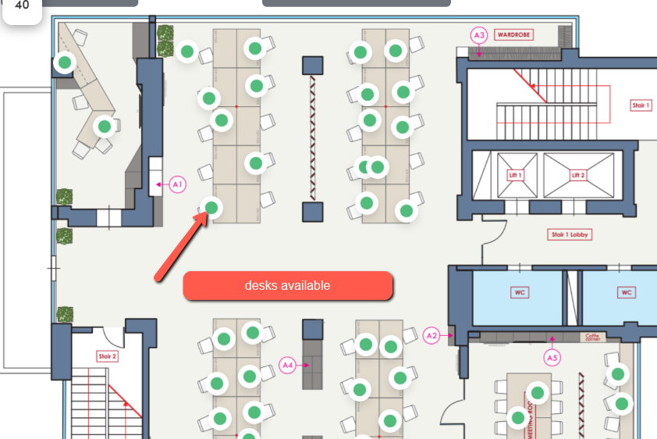

USERS:

1. Log in into the system.
2. Choose location/office.
3. Health check questionnaire,
4. Find floor/map where available work desks
5. Choose a desk to be booked
6. Choose day/multiple days the desk to be booked
7. Confirm/ deny booking.

When booking confirmed, the stated desk becomes not available to be booked by other user(s).

The user that booked the desk receives a confirmation where desk location and date the desk is booked.

User that booked the desk can cancel booking.

In case the booking is canceled, another booking required.

Health check questionnaire:  
Q1: Are you showing any symptoms of COVID-19 (cough, sore throat, shortness of breath)?  
Yes/No  
Q2: In the past 14 days have you had close contact with someone who is confirmed as having COVID-19?  
Yes/ No   
Q3: Have you traveled internationally in the last 14 days?  
Yes/ No.  
Q4:Did you get vaccinated for COVID-19?  
Yes/ No.

Access to office confirmed and confirmation the desk is booked:

Q1: No  
Q2: No  
Q3: No  
Q4: Yes or No

Q1: No  
Q2: Yes  
Q3: No  
Q4: Yes

Q1: No  
 Q2: No  
 Q3: Yes  
 Q4: Yes  
  
For other cases the following message should appear.   
  
Access to the office denied. Please contact the Centre Director or the Line Manager.

Statistics:

App should track and provide statistic for all requests submitted, daily, weekly and monthly reports per location and overall Amdaris group.